A REPORT ON

IOT BASED GERIATRIC HEALTH CARE SYSTEM

In fulfilment of the course: EEE G627

Submitted by

**PRATEEK MAHAJAN 2017A3PS0317P**

**TRIVIKRAM CHOUDHURY 2017A8PS0568P**

**BAKUL AGRAWAL**

Instructor-in-Charge: Dr. Meetha Shenoy



**BIRLA INSTITUTE OF TECHNOLOGY & SCIENCE, PILANI RAJASTHAN, 333031  
DECEMBER­­, 2020**

Problem Statement Description

This report describes a model of a geriatric IoT-based health care system. Within our system, we are defining 4 types on nodes (1 additional to what was provided in the problem statement)-

1. Wearable nodes/ watches worn by the users – These are essentially the end nodes that detect irregularities as and when they occur and transmit it to the concerned nodes to take relevant action.
2. Static nodes in the building – These are essentially nodes in the building that are present for localisation of users and information routing purposes.
3. Mobile Robot – This essentially a robot that responds to an emergency and goes to the required area as per the information given to it by relevant nodes.
4. Base Station nodes – We are adding an additional type of static node in our design which essentially acts as a cluster head and a gateway for other nodes in the system. Details of its working are present below.

Assumptions

1. We are considering an apartment scenario where we are essentially designing a system for 1 floor. We assume that each floor consists of 4 separate homes.
2. Within each home, we are assuming the presence of 1 base station node, and multiple static and wearable nodes. For the purpose of localisation, we are taking 3 static nodes in every room. Essentially, this also serves the purpose of adding an aspect of redundancy to the system, that is, if 1 node stops working, it doesn’t mean that system fails; the presence of 2 nodes is sufficient for the system to keep running.
3. Further, rooms with common walls may share a node, thereby reducing the cost of the system
4. Please note that any Xs or Os in the figure below are not simply suspended from the air; rather they are on the ceiling of the house.

Schematic Diagram of an Apartment



Where X stands for a static node in the building and O stands for a base station.

Schematic Diagram of a Floor

Essentially a floor will consist of 4 such apartments (as given above) with a configuration as shown below

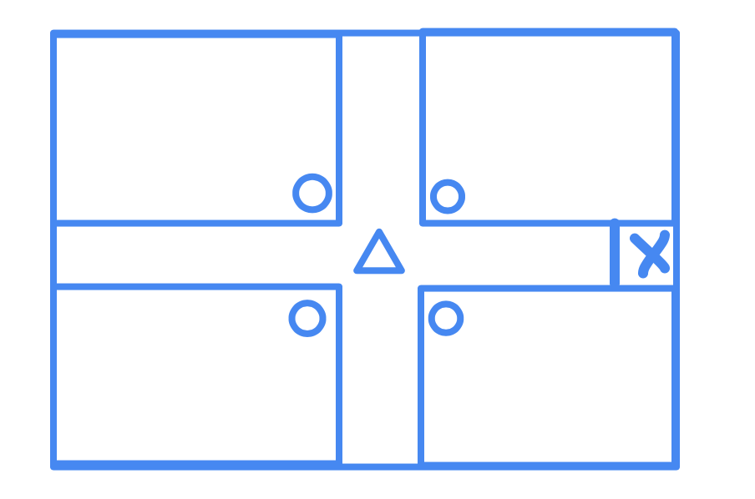

Where the rectangles are apartments and circles are the base stations of the respective apartments. The triangle is essentially a repeater used for communication with the mobile node (marked as X) and between base stations. The mobile node starts its motion from the its docking area (where it is currently present).

We consider an apartment as the basic physical area unit in our design. We design the network such that each apartment is independently capable of performing all tasks. But, in case of multiple apartments in the same level, we can use the floor plan design.

Capability of Nodes

1. Wearable nodes – as defined in the problem
2. Static Nodes – Essentially routing nodes which forward information regarding RSSI to the base station for localisation in addition to the information given to them by wearable nodes
3. Mobile Nodes – as defined in the problem
4. Base Station Nodes – connected to the internet, responsible for processing data given to it and taking necessary action (raising that a node is faulty, calling mobile node through the repeater etc etc)

Types of Communication

1. Routine Communication – Essentially this refers to the transfer of data from the wearable nodes to the base station and the uploading of the aforementioned data to the internet. Essentially, we have only 3 sensors on our device – ECG sensor, oximeter and temperature sensor and will be transferring only the below data to the base station-
2. 1 byte of oximeter data for every minute
3. 2 bytes of temperature data for every hour
4. 1 byte of heart rate data generated every 1/60 seconds (sampling frequency of 60 Hz)

All calculations regarding heart rate, the oximeter and temperature shall be done on the wearable node itself. This data shall be sent to the base station for uploading once every 24 hours. The base station shall also process the data to analyse sleep patterns and use other parameters (such as weight, gender and age) to try and predict future health conditions (or existing ones that haven’t been diagnosed yet). Therefore, on a daily basis, we have approximately 5.2 MB of data being generated for analysis and uploading by each wearable node.

Another routine communication that occurs (if setup by user) is the sending of reminders to a wearable node from the base station for activities such as exercising and having medicine.

1. Emergency Communication –

In case of a seizure of any other problem faced by the user, the wearable node essentially broadcasts an emergency communication message to sink to inform the sink of such a situation so as to get it to direct the mobile node to the location of the user. Further, it informs the concerned authorities of such an occurrence through the internet.

1. (refer to the above schematics for the complete deployment diagram as well as the nodes and their capabilities)
2. The main performance metrics that we are considering for our network are the life of the wearable device, latency in sending critical information and fault tolerance in case of node failures.
3. All the nodes in our project run on the 6LowPAN standard with their PHY and MAC layers as 802.15.4 (MAC also consists of a 6LowPAN layer). We are using the RPL routing layer for routing in the network such that the objective function being used uses the minimum hop count metric to do so.
4. The physical layout of the nodes and their capabilities can be found above. The below diagram depicts the network stacks used in our design-



Essentially, the stack on the left is used by the static nodes, the wearable nodes and the mobile node, while that on the right is used by the base station in each of the respective houses. The 6LowPAN stack was chosen because it is supposed to be approximately as efficient as ZIGBEE in terms of power consumption and has lower latency because of the reduced overhead. In addition, 802.15.4 can be designed with a transmit power corresponding to a sufficient range to localise the wearable nodes in the vicinity of the static nodes. Therefore, the above is a suitable stack for communication. Procotols like Wifi cannot be used by the wearable node (too much power) and Bluetooth cannot be used for localisation in bigger rooms and have a significantly greater overhead connecting to the internet.

Within the RPL, we are using the minimum hop count metric to come up with relevant paths for the information transfer. Essentially we chose this because it ensures minimum latency to communicate with the base station.

The base stations in each of the houses would be connected to the internet.

1. The wearable node itself will perform some operations such as fall detection and inform the base station to take measures as mentioned earlier, while the accumulated data from the nodes will be used to come up with the user’s location at the base station itself. Further, analysis of long term problems shall take place at the base station itself. If any such problems are detected, the user and caretaker are notified and necessary actions are taken. Further, the wearable node receives notifications at specific times from the base station, wherein the user is reminded to take his medicine/ exercise as specific times of the day.
2. The restrictions and challenges of designing a network for such a system are-
3. Limited capability and power of the wearable nodes
4. Fault tolerance is essential, as an emergency scenario could occur at any time
5. Privacy issues are a major concern in such networks. It is important to consider them
6. Time Synchronisation – Since routing occurs in our system through a DoDAG/hierarchical structure, we are planning on using the FTSP time synchronisation protocol for the purpose of time synchronisation.
7. Localisation – We are planning to perform localisation using the RSSI method. Essentially localisation is done in 2 scenarios – an emergency scenario and an hourly check by the static nodes. In an emergency scenario the RSSI of a wearable node’s “help” message is calculated and sent to the base station, which uses the data it gets from all nodes to get the location of the user. Apart from that, every hour, the static nodes forward RSSI information of control messages sent by the wearable node (time sync, reminders, etc) to the base station which does the necessary calculations to get the location of the user. This information is NOT updated to the cloud or shared with anyone.
8. Medium Access Control – The network stack used has already been mentioned. Essentially, we chose 802.15.4 because of its compatibility with 6LoWPAN. In addition to that, the presence of contention free periods make it suitable for this application as they can be used for the quick transfer of emergency signals and reminders as when necessary. (We particularly want to use the beacon-enabled slotted CSMA MAC protocol)
9. Routing – We are using the RPL routing protocol with a minimum hop count metric. This is essentially used to ensure fast data transfer (routing paths already known before sending data).
10. The addressing scheme used is a default 82.15.4 addressing as is implemented by Contiki. This is done to be able to create enough unique IDs in the network while maintaining a low overhead in the datapacket.
11. The layers implemented are all layers below the transport layer, i.e., the UDP layer, IPv6 layer, the 802.15.4 MAC layer and 802.15.4 PHY layer. Here, we implement these layers to showcase the communication between the static and mobile nodes, and also between the static nodes and the internet where the patient/elderly person’s vital data can be accessed by authorized caregivers and doctors. Thus, a router level simulation has to be done. The application layer can be ignored, as the scope of the assignment is not to implement the actual programs which will ask for the data.
12. Yes, this architecture is scalable. Essentially, it simple requires an ethernet connection a home through which the data will be uploaded into the internet. The positioning and number of nodes required will depend on the house but apart from that, this architecture is easy to scale.
13. We have tried our best to remove vulnerabilities from this system, both security and fault tolerance associated. In terms of security, we are assigning every node to a private and a public key, according to AES encryption standards. Essentially, if information is intended for a particular node, it will be encrypted with public key of that node and decrypted with its private key. This ensures that only that concerned nodes will be able to read the data. (Note that only the payload will be encrypted). Further, sensitive data such as location data will not be sent on the network, rather it will be calculated by the base station and KEPT AT THE base station alone. Finally, the base station will also have a mechanism built into it to detect wormhole and MITM attacks. Since each room has 3 nodes present, if any one of them are compromised/malfunctioning, the base station detects by comparing the behaviours and values obtained from the other nodes and flags such nodes to remove them from the routing scheme. This mechanism is also used in the event of a node failure where the node failure is detected and call is sent to have the node replaced. Finally, to further increase the network’s ability to withstand fault tolerance, another node with base station’s capabilities is present near it. Unless the base station fails, it essentially acts as a static node, but takes over when the base station fails.